Sherwood Park PAC Newsletter

Email: sherwoodparkpac@gmail.com
Facebook: https://www.facebook.com/sherwoodparkpac/
Web: http://sherwoodparkpac.weebly.com/
School Twitter: @SherwoodPark44
School Email: www.sd44.ca/school/sherwoodpark

June 2018
EVENT CALENDAR  PAC Meetings 2018/19  7:00pm in the school library  - Sept. 26, 2018  - Nov. 14, 2018  - Jan. 23, 2019  - Apr. 10, 2019  - May 29, 2019  Hot Lunch Dates  June 11 Magic Lunch Box  June 18 Sushi  June 22 Subway  Hold the date for these fun parent and family events next year:  - Trivia night - Nov. 23, 2018  - Spring dance – Mar. 8, 2019  - Pancake breakfast – Dec 21, 2018  - Carnival – June 20, 2019  We would like to thank the Coast Salish people, specifically the Squamish Nation and Tsleil-Waututh Nation, whose traditional territory North Vancouver School District resides on. We value the opportunity to learn, live and share educational experiences on this traditional territory.  SPIRIT WEAR  Show your school spirit with some of our Sherwood Park logo gear! To purchase any of these items email the PAC to check for sizing and arrange for payment/delivery. Please use “Spirit Wear” as the subject line.  Logo T-shirt (Youth)  $18  Collegiate T-shirt  $13 (Youth)/$14 (Adult)  Logo Hoodie  $40 (Youth)/$45 (Adult)  *limited sizes available  Collegiate Jogger (Youth)  $28  *limited sizes available  Logo Water bottles and Mugs  $10  (Available for purchase at the office)  COMMUNITY  SUPPORTERS  RASMUSSEN GROUP  If you buy/sell your home or refer a friend to the Rasmussen team, 10% of their earnings from that sale come back to the PAC!  www.yournewpad.com  IT’S THE MORTGAGE GUY  New mortgages or debt refinancing? Consider Jonathon Adams of the Verico Nova Team as your local mortgage broker, and 10% of earnings are donated back to the PAC!  www.ItsTheMortgageGuy.com  NESTERS MARKET  When you are grocery shopping, tell them you are school #2 and the loyalty points will be directed to Sherwood Park.  COMMUNITY  SUPPORTERS  TOOKA FLORIST  10% of your order comes back to our school when if tell them you are a Sherwood Park family. www.tooka.ca  A big THANK YOU for supporting our Spring Dance 2018!  BEAUTIFUL EYES  Purchase glasses for your family and a portion of the proceeds are donated back to the school.  www.beautifuleyes.ca | CARNIVAL 2018 IS ALMOST HERE!!!  We are getting excited about this year’s Carnival on June 21st.There is fun for all ages and we are looking forward to a fun-filled family evening.  Pre-order Sales BBQ and Fair Tickets Now!!!  Don’t miss your chance to order your Carnival fair and BBQ tickets at a discount before the June 10 deadline. CLICK HERE log into your Munch a Lunch account to place your order and pay by credit card. After the deadline, you can purchase tickets at the Carnival (only cash or cheque will be accepted at the Carnival).  Volunteers Needed!!  We cannot pull off Carnival without your help!! We will need over 120 volunteers to make it work. There are plenty of different roles to suit your schedule and talents during the day to help set up, at the event, at the end of the evening and the following day. Please take a look at the volunteer sign-up page to see where you can help and sign up for a shift.  SIGN UP HERE!  Can we Borrow your Tent?  Do you have a portable canopy that we can borrow? We could really use it to help create some shade areas for the kids and volunteers. Please email sherwoodparkpac@gmail.com with the subject line “Carnival Canopy” to let us know. We will ask you to drop off tents between Monday June 18th and Wednesday 20th in the hall outside the multipurpose room (outside entrance under the office). Please ensure your tent is clearly labeled with your name and phone number. Ideally, you could pack up your tent and bring it home with you at the end of Carnival. Otherwise, you can pick it up on Friday or the following week in the same location that you dropped it off.  YEAR END PAC MEETING  May 30 PAC meeting write-up:  At the final PAC meeting of the year, parents in attendance approved the 2018/19 PAC budget. The budget covers items like performing arts, sports, and sexual health education programs to supplement the school curriculum, new drums for the music class, first aid training for grade 6 students, as well as a teacher’s discretionary fund, allocated per teacher. Full details on the budget are contained in the May 30 meeting minutes.  Election of next year’s PAC executive also took place. Your 2018/19 PAC is:  - Gina Madeo, Co-chair - Chris Ricard, Co-chair  - Penny Swords, Co-Chair - Anthony Lyons, Treasurer  - Sharon Boglari, Secretary  All parents are members of the PAC and we encourage your feedback and support. If you would like to get involved in your school community, you can check out a list of volunteer positions at http://sherwoodparkpac.weebly.com/get-involved.html, or contact us directly at sherwoodparkpac@gmail.com.  We are fortunate to have a very active parent community at Sherwood Park. Thank you to all the wonderful parents who have supported our school over the last year!  OVERCOMING THE WORRY IMP  Last month, Registered Clinical Counsellor Sharon Selby visited Sherwood Park to present practical tips to help parents understand childhood stress and anxiety. More than 35 parents attended the talk.  Over the last 20 years, Sharon has seen the rates of childhood anxiety sky rocket, particularly in teenagers -- which can lead to unhealthy coping mechanisms such as cutting and drugs. Sharon explained how the physical reaction that our bodies have to anxiety are the same as those for fear or danger (fast breathing, sweaty palms, butterflies, etc.). While these are responses to real danger, children need to learn how to manage these “false alarms” in situations that don’t present a danger.  One strategy that Sharon uses to help children manage anxiety is to understand the brain science behind their physical reactions and how “big emotions” stimulate the Amygdala or the brain’s alarm centre. She works with children and families to use mindfulness and self-regulation techniques to challenge irrational thinking – and be the boss of their “worry imp.”  For more details on anxiety, visit www.SharonSelby.com. Sherwood Park school library and counsellor now have a number of copies of Sharon’s book Surfing the Worry Imp which provides hands-on, fun activities for children aged 5-10 to practise mindfulness.  PAC FUNDED SPORTS PROGRAMS  The PAC supports an annual sports program that supplements our students' regular physical education and provides access to activities that they may not otherwise be exposed to. This year the PAC provided Gym Sense for all primary grades and Dragon Boating for intermediate students.  Dragon Boating was a great opportunity to take advantage of the neighborhood we are fortunate to live in and was a great exercise in team work.  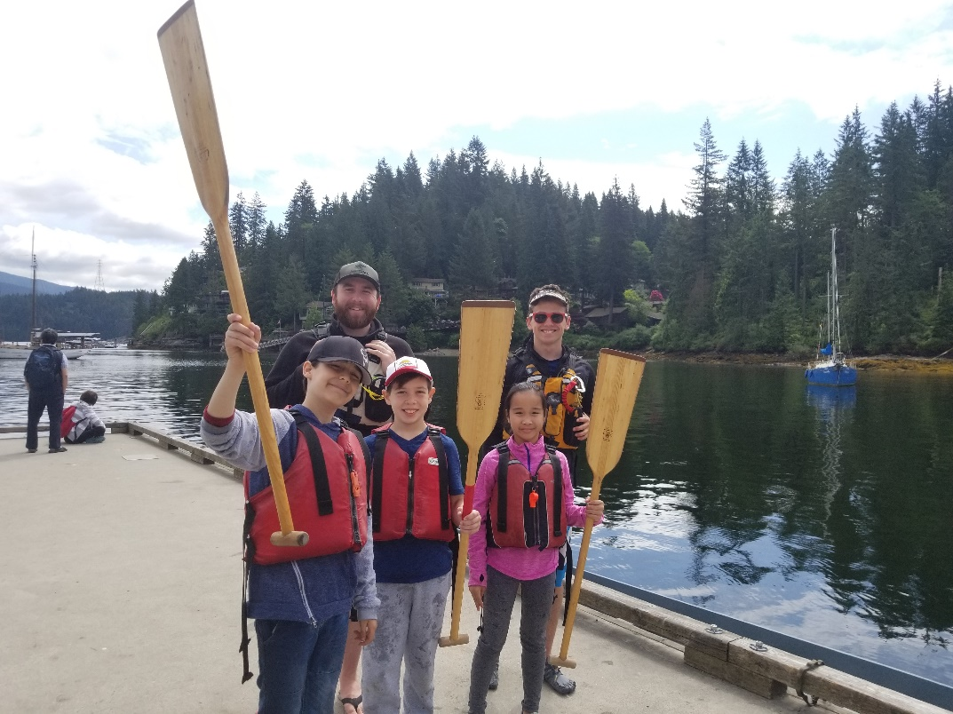  TRAFFIC UPDATE  A HUGE thank you to the Safety Patrol Team of 2017/18! Thank you for playing a big part in keeping our students safe on the roads! Your commitment and volunteering of your personal time has been greatly appreciated!  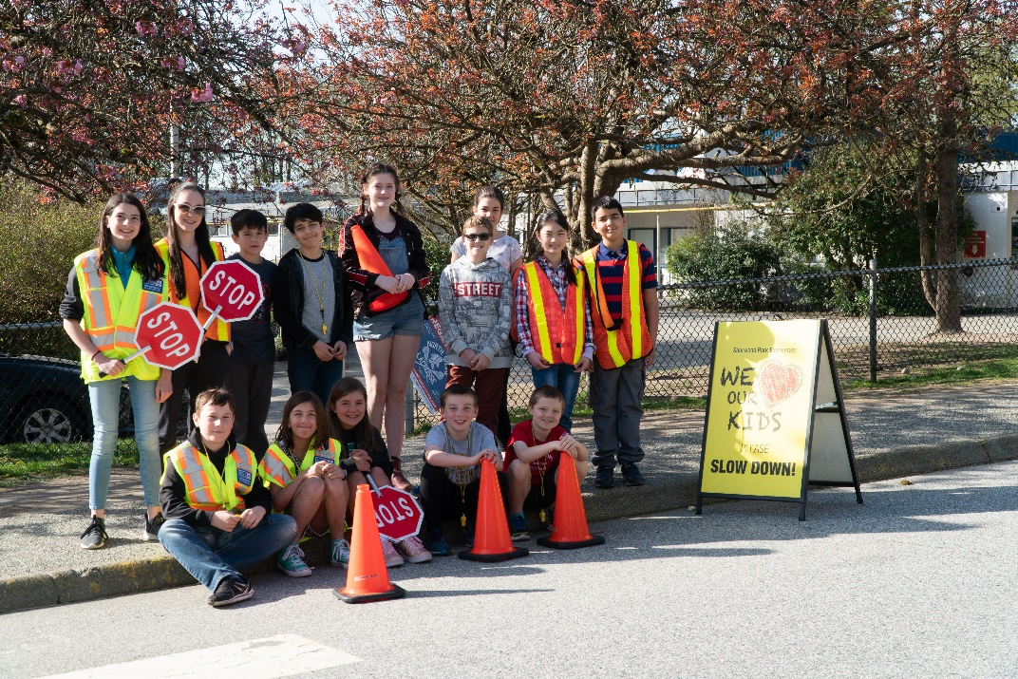  Safety Patrol Students at the Sherwood Park crosswalk (3 students are missing from the photo)  Please remember to use the area in front of the school for drop-off and pick up ONLY. Do not leave your vehicle to go inside the school. If you are picking up an older child after school, please consider having them meet you a little further away such as Felton Road to avoid congestion at the front of the school and in the cul de sac.  Have a safe and happy summer!

